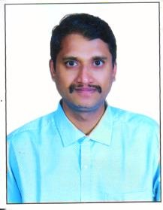

Dr. Rudreswar Rao is the Principal of College, He is good natural person. His age is about 40 years. He is Professor  Department of Kayachikitsa (Teacher Code AYKC00748). His Registration No. is 21694. He has joined this college on dated 02/03/2022. His Permanent address is Nandielugu village Behind Kanaka Durga Temple, Dhonka Road Andhra Pradesh Tenali 522306. His present residence is Prem Raghu Ayurvedic Medical College Teacher’s Colony, Agra Road, Hathras. His **Mob. No. – 9985085255**& Email is [drrudreswar83@gmail.com](mailto:drrudreswar83@gmail.com) was the principal of this college.

|  |  |
| --- | --- |
| Name of the Principal | Rudreswar Rao |
| Date of birth | 27/07/1982 |
| Designation | Principal |
| Teacher Code | AYKC00748 |
| Date of Joining | 02/03/2022 |
| Email ID | [drrudreswar83@gmail.com](mailto:drrudreswar83@gmail.com) |
| Mobile No. | 9985085255 |
| Local Address | Prem Raghu Ayurvedic Medical College Teacher’s Colony, Agra Road, Hathras |
| Permanent Address | Nandielugu village Behind Kanaka Durga Temple, Dhonka Road Andhra Pradesh Tenali 522306 |