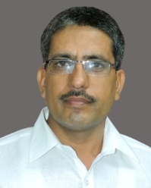

**Dr. Pradeep Kumar Rao**

Registrar :Mahayogi Guru Gorakhnath Ayush University

D.O.B. : 01-05-1970

Mobile No. :9794299451

Address : Gram Post Nagba Khas Distt Devariya (U.P.)