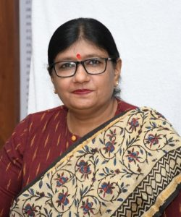

**Prof. Ashu Rani**

**Vice Chancellor**

**Brief curriculum Vitae**

**Professor of Chemistry, Director Research at university of kota – india**